We expect catastrophe' – Manila, the megacity on the climate frontline
IPCC report warns life in the Filipino capital and other coastal cities will get much worse in many ways as temperatures rise

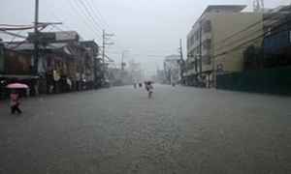
Residents walk through a flooded street as heavy rains continued in Manila on August 20, 2013. Flood-battered residents of the Philippine capital fled their homes or sat on rooftops on August 20 as relentless monsoon rains, which have killed seven people, submerged more than half of Manila. Photograph: Noel Celis/AFP/Getty Images

John Vidal in Manila
Monday 31 March 201406.00 BST
Last modified on Monday 20 July 201513.36 BST
http://www.theguardian.com/environment/2014/mar/31/ipcc-climate-change-cities-manila
Joshua Alvarez and his family fear for their lives when the monsoon rains come. Last August their two-bedroom flat in Manila was flooded when severe tropical storm Trami dumped 15 inches of rain (380mm) in a few hours and the local reservoir overflowed. They fled to a flyover with thousands of others as five large areas of the capital were inundated with muddy waters up to three metres deep and a state of calamity was declared in three Philippine provinces.
In 2012, typhoon Haikui battered the megacity of 12 million people for eight days, but when tropical storm Ondoy hit Manila in 2009 and a month's worth of rain fell in a few hours, the city came close to catastrophe. Nearly 80% was flooded, 246 people died and hundreds of thousands had to be evacuated.
According to the Intergovernmental Panel on Climate Change (IPCC), the UN's climate science panel, life in the world's coastal cities is about to get much worse as temperatures rise a further 4C over the century. Manila, Guangzhou, Lagos, Ho Chi Minh City, Kolkata, Shanghai, Mumbai, Tianjin, Rangoon, Bangkok and 100 others in high-risk tropical and subtropical regions are most vulnerable. They can expect to be swamped more often by tidal surges, battered by ever stronger typhoons and storms, and hit by deeper droughts.
Not only will food in cities become more expensive as crops are hit by weather extremes, but cities such as Manila can expect more power shortages, disease and interruption of water supply; nights will become hotter and they will have fewer cool days. Add to that the pollution cloud that already hangs over most Asian cities, and urban life may become unhealthy, unpalatable and more unpredictable, the report suggests.
"Heat stress, extreme precipitation, inland and coastal flooding, as well as drought and water scarcity pose risks in urban areas, with risks amplified for those lacking essential infrastructure and services or living in exposed areas," says the report, which makes this forecast with "very high confidence".
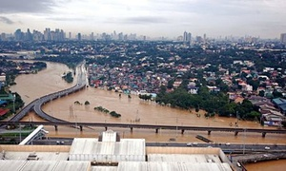
Flooded areas in Marikina, east of Manila, Philippines. Photograph: Philippines Department Of National Defense/AP
As the Philippines recovers from the estimated $36bn (£22bn) of damage caused last November by super-typhoon Haiyan (known locally as Yolanda) – the most powerful storm ever to have made landfall – the state meteorological office,Pagasa, says that climate change is already hitting the country hard.
"There has been a significant increase [in the last 30 years] in the number of hot days and warm nights and a decreasing trend in the number of cold days and cold nights. Both maximum and minimum temperatures are getting warmer. Extreme rainfall events are becoming more frequent. In most parts … the intensity of rainfall is increasing. The number of cyclones is less than it was, but they are getting stronger," said a Pagasa spokesman.
"We had a foretaste with Yolanda. No one had experienced winds of 300 kilometres per hour before. The whole city of Tacloban was destroyed. Now we know we can expect more aggressive Yolandas coming our way," said Alicia Ilaga, head of climate change in the government's agriculture department.
"We had never seen anything like Yolanda before, but we see typhoons coming to areas where they were never experienced before. It's an early warning. It has taken a disaster like that for people to realise that these extremes are not natural. If we are hit by extremes every year we will go back to square one," she said.
"Every city and every sector of our country and society is at risk," said Yeb Sano, the Philippine government's climate change commissioner. "The IPCC tells us it will probably get 4C warmer. That means everything will be compromised, from food and energy to settlements. We are not ready. The challenge is too huge. I cannot imagine what would happen if a typhoon the strength of Yolanda hit Manila or the second city, Cebu. It would be a global disaster. It will take us 20 years to recover from Yolanda as it is. We lost 1m homes then. We are very vulnerable."
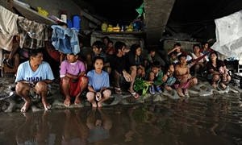
A group of Filipino farm workers huddle beneath a bridge to seek shelter from rains and rising floodwaters. Photograph: Jay Directo/AFP/Getty Images
The government is urgently drawing up detailed maps of all vulnerable areas, but says that the money is just not there to protect 100 million people living in both cities and rural areas. "Rich countries tell us to become climate resilient. We agree, but who pays? We have received possibly $5m, from the World Bank for studies to adapt to climate change, and that is all," said Ilaga.
Dennis Posadas, Manila-based fellow of the Climate Institute in Washington and Philippine technology consultant, said climate change would bring ill-health and water rationing to cities such as Manila and Cebu, along with more intestinal and mosquito-borne diseases such as dengue fever, Japanese encephalitis and chikungunya fever. "If temperatures go up 3-4C as the IPCC expects, then evaporation will be greater in reservoirs, which will mean less water, and diseases like dengue will increase. Mosquitoes will breed more easily. People will get heatstroke."
Manila, he says, is already several degrees warmer than surrounding areas in the day and is stifling at night because of the urban heat-island effect, which releases the heat stored in concrete, roads and buildings at night. "A 4C rise in temperature will make life unbearable and air conditioning an absolute necessity," he said.
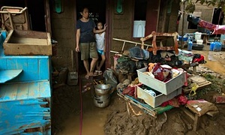
Edna Mendoza stands with her daughter at the door of their home as they clean up the mud and debris from the floods in Manila, Philippines. Photograph: Paula Bronstein/Getty Images
Posadas, who has moved his family out of the city for health reasons, says climate change will hit the poorest hardest. "Tens of thousands of people in Manila live in shanty towns that are in the way of the floods. These people will be the most vulnerable. What the IPCC report means is that those areas that are not already flooded when it rains heavily will be in future. Everything will become more extreme. Subsidence will be exacerbated, high temperatures will become unbearable. These days 32C (90F) is common and lots of people still do not have fridges – so food will go off. Climate change will slow down economic growth, further erode food security, trigger new poverty traps and create hotspots of hunger."
Dante Dalabajan, Oxfam's programme co-ordinator in Mindanao, who worked on the Yolanda emergency, said: "The danger is that Filipinos will be trapped in a vicious cycle where the more the planet heats up the more they adopt the technologies they think will help, but will actually exacerbate the problems. The potential for epidemics in cities is huge. You cannot just evacuate millions of people."
Alvarez said: "We expect catastrophe now. But what can we do? We don't need the scientists to tell us any more that we are vulnerable. We just need help. We can see what is happening. We would all move if we could, but we are trapped."

