YouthToSea Application Process:

We are looking for youth (14-21) in British Columbia who are passionate about ocean protection and sustainability. Youth to Sea is a great opportunity to protect our oceans, develop your leadership skills and be part of a great team of like-minded youth.

If you are interested in joining The YouthToSea program, please fill out our application form here:

https://docs.google.com/forms/d/1EgjvDqzYYCv49EEHYSlHBSg3LO716rV3-7hv59uR8H8/edit

OR email the answers to the questions below to michelle.bienkowski@ocean.org with the subject: YouthToSea Application.

Once you have filled out the form a member of our team will be in contact to discuss your application.

Youth interested in taking on more responsibility and becoming a member of our executive council should indicate so on their application. To be selected as a council member you must first complete 3 months in the YouthToSea program to demonstrate your commitment and ability to lead ocean conservation projects. Students who have a history of organizing ocean conservation events may be considered for a council position immediately.

If you are outside of this age range but interested in joining as a professional advisor, please contact us. We have opportunities for older youth to become mentors as well as volunteer opportunities for anyone looking to get involved.

If you have any questions about application or joining our program, please email michelle.bienkowski@ocean.org.

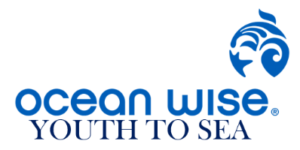
YOUTHTOSEA APPLICATION FORM:

Name:

Age:

Current City:

Email Address:

Education Level:

How did you hear about this opportunity?

Tell us about yourself and why you are interested in participating in YouthToSea.

Are you available for a group call once a month and 20-30 hours of outreach throughout the year?

Which position are you interested in (member, executive council, mentor)

